**EE 464**

**STATIC POWER CONVERSION-II**

**Fall 2022-2023**

**Homework 2**

**Magnetic Design of an Isolated Power Supply**

**Hiper-Optik Basküler Converter**

Ömer ŞEN – 2305415

İsmail MACİT - 2305084

Yasin Enes ÇALIŞKAN - 2304319

## Topology Selection

There are many isolated topologies studied as DC-DC converter such as flyback, forward and push-pull converter. We decided to use push-pull converter due to several advantages.

1. Flyback Converter

Flyback converter is widely used and a good option for the project; however, it is not preferred.

|  |  |
| --- | --- |
| **Advantages** | **Disadvantages** |
| Widely studied | Bigger core |
| Easier to control | Large Lm causes voltage spikes |
|  | Needs a bigger snubber (less efficient) |
|  |  |

2.Forward Converter

Forward converter solves the problems caused by Lm; however, it requires

|  |  |
| --- | --- |
| **Advantages** | **Disadvantages** |
| Better core utilization | Three windings |
| Output inductor gives better output current | More components |
| Less energy storage needs in the core (gapless) | Gain changes a lot in DCM |

3.Push-Pull Converter

Push-Pull converter solves the problems and utilizes core the best.

|  |  |
| --- | --- |
| **Advantages** | **Disadvantages** |
| Better core utilization | Four windings |
| Output inductor gives better output current (twice frequency) | More components (2 diode- 2 mosfet) |
| Smaller transformer | Harder control |

## Push-pull converter topology is selected because it utilizes core better. Moreover, it has less ringing due to Lm. Output frequency is naturally doubled reducing inductor and capacitor size.

## a)

Chosen topology for the hardware project is push-pull converter.

Since

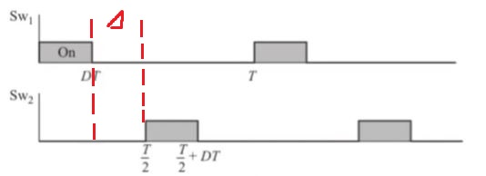

Based on the duty cycle and Vin-Vout relation, Nseconday/Nprimary=40/9 is chosen.

Therefore, duty cycle range is found as

## b)

* In order to minimize the leakage inductance, E core is chosen. The windings will be on the middle leg to minimize the leakage inductance. Also, E cores are much easier to obtain in the market, which is another reason to choose E core. Using the guideline given on magnetics.com, we determined the and values as follows;

Then we calculated for required core.

Chosen core is CF139EE2507 (

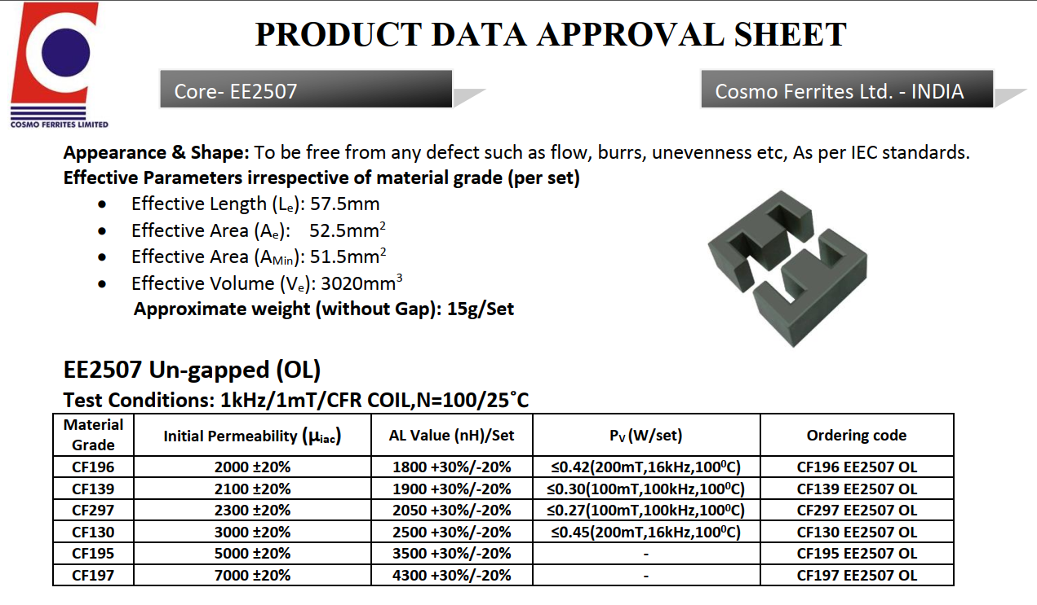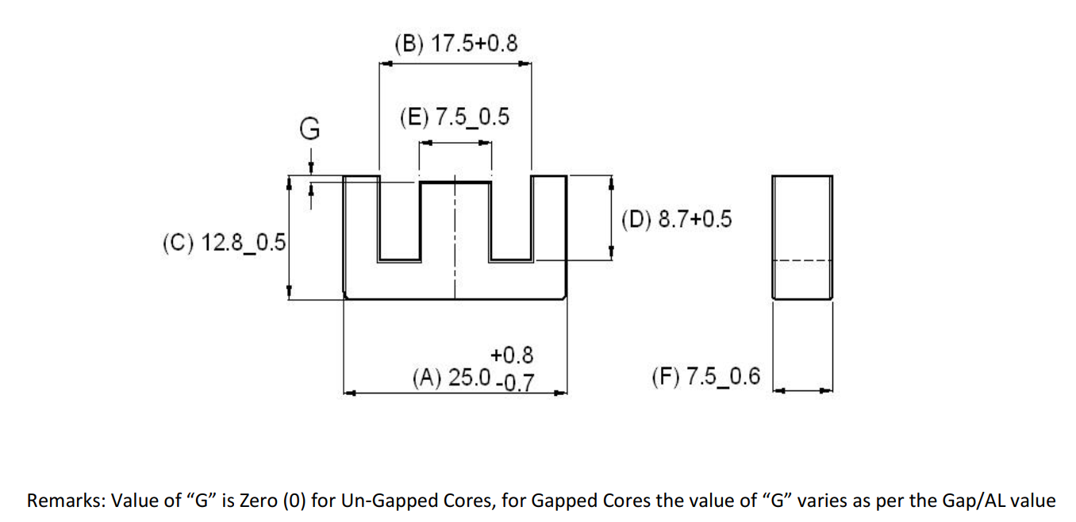

* Number of turns and Lm
* Cable selection

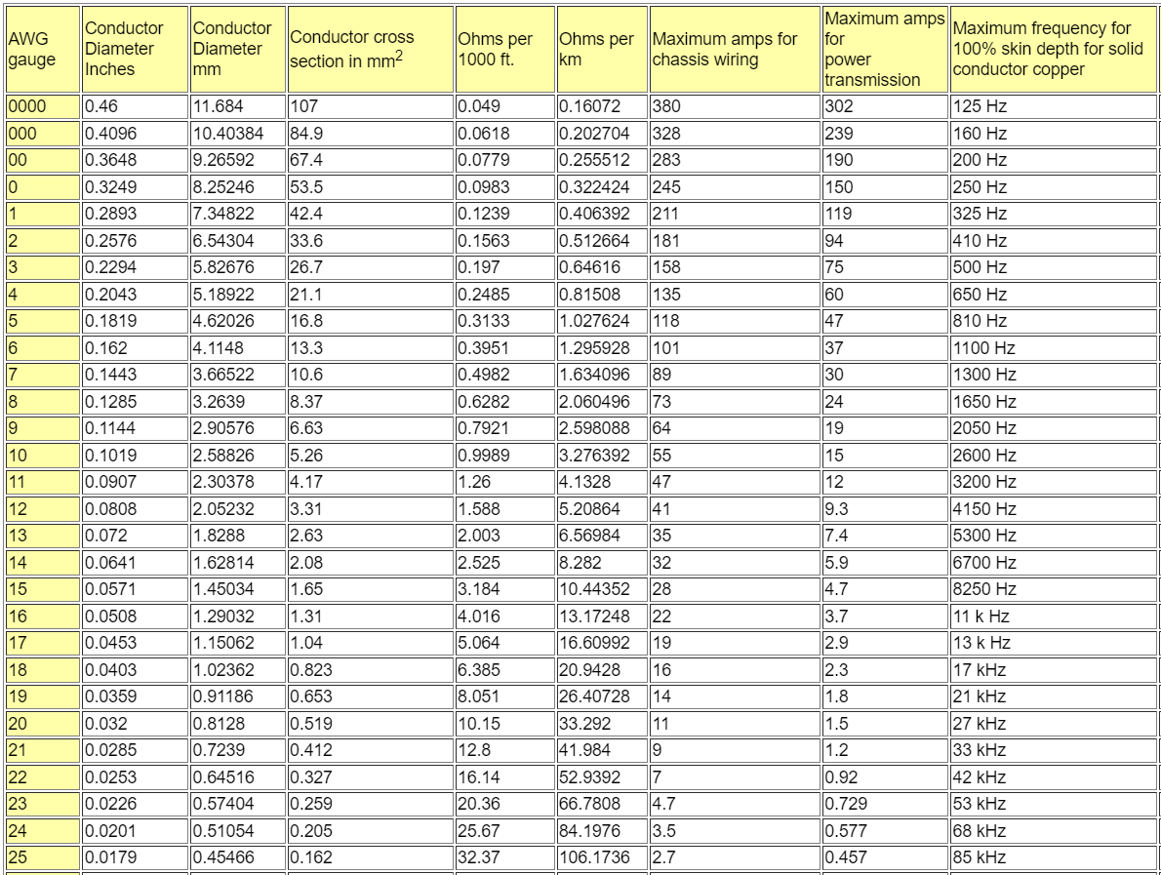

1x22AWG for secondary, which can operate with 100% skin depth at 40kHz.

2x22AWG for primary, which can operate with 100% skin depth at 40kHz.

* kcu fill factor and copper losses.

0.34 fill factor is a reasonable fill factor for the transformer.

Since cables are used with 100% skin depth, AC and DC resistances are expected to be same.

* Core losses of the transformer

In the datasheet, 0.42W/cm3 is indicated for 0.2T operating condition.

Even if the ratio of Pcopper to Pcore is very small and in an ideal case they should be equal, it is decided to not iterate since summation of the losses is not very large.

**c)**

Converter is simulated using Simulink with the following model in Figure xxx.

diyagram içeren bir resim

Açıklama otomatik olarak oluşturuldu

Figure Push-Pull Converter in Simulink

Input and output currents, switch voltages and other measurements gave us the expected results with the theoretical ones shown between Figure 2-10.

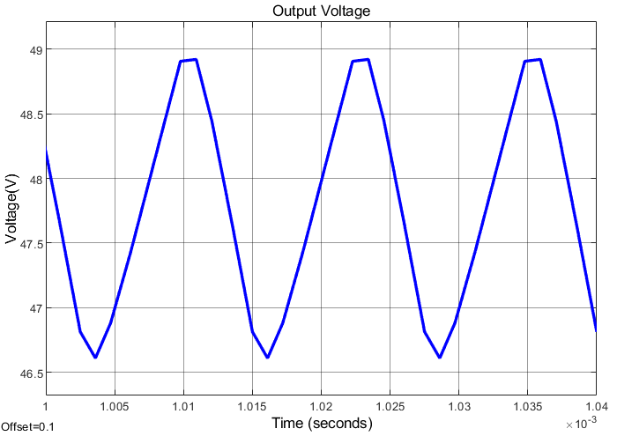

Figure Output Voltage of Push Pull Converter with 18V Input

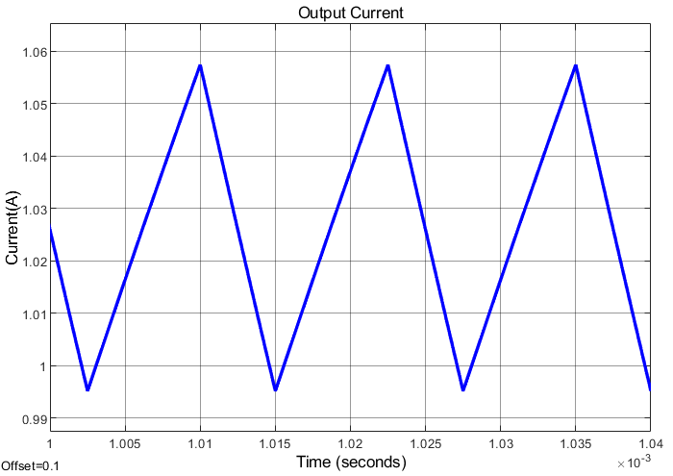

Figure Output Current of Push Pull Converter with 18V Input

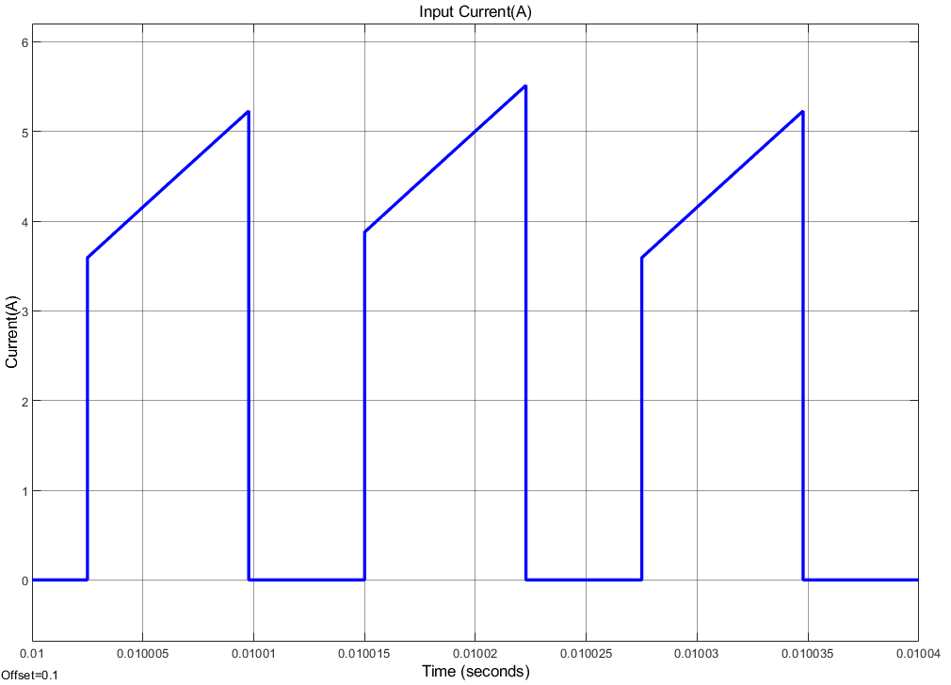

Figure Input Current of Push Pull Converter with 18V Input

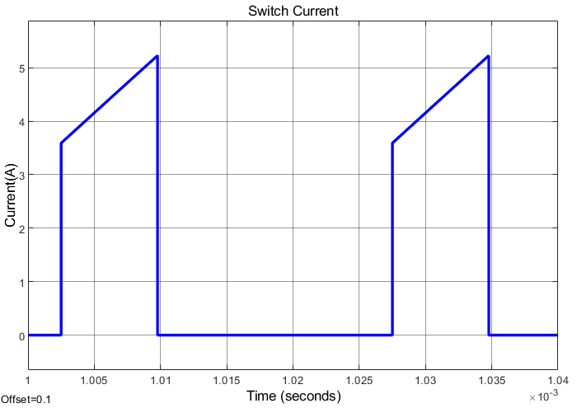

Figure MOSFET Current of Push Pull Converter with 18V Input

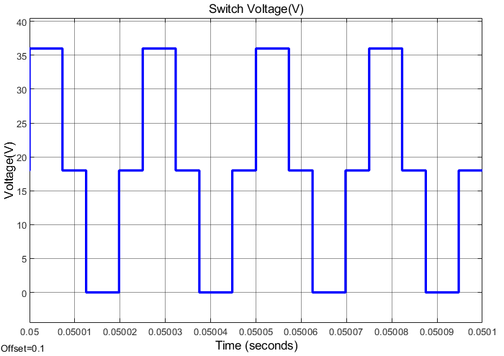

Figure MOSFET Voltage of Push Pull Converter with 18V Input

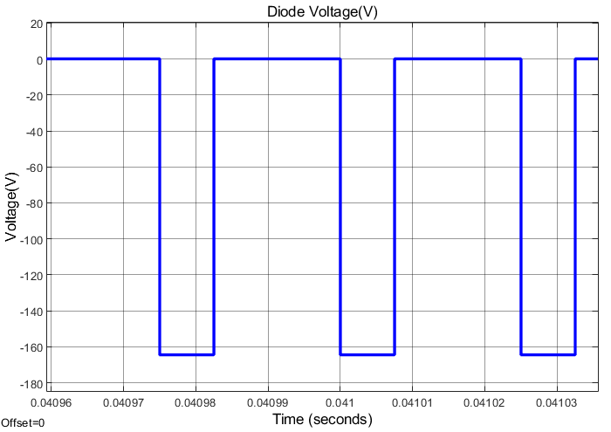

Figure Diode Voltage of Push Pull Converter with 18V Input

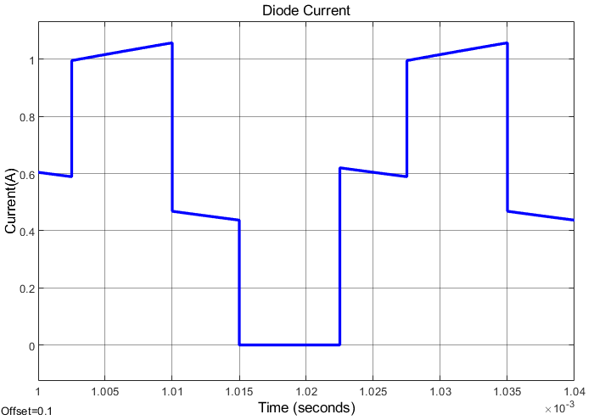

Figure Diode Current of Push Pull Converter with 18V Input

12V inputs and outputs have similar shapes they are only scaled.

**d)**

To get into the DCM mode output current gets around 0.27A average (180 ohm resistive load 18Vinput).

çizelge içeren bir resim

Açıklama otomatik olarak oluşturuldu

Figure Output Current Before DCM with 18V

Discontinuous conduction mode is determined using the primary coil currents. When the waveform start to corrupt it means we cannot magnetize and demagnetize our core properly to work in CCM.

|  |  |  |
| --- | --- | --- |
| Mode | Min Current(mean) | Max Current |
| CCM | 0.2A (18V) | 1.65A (12V) |

## e)

For use in the circuit, P60B4EL MOSFET (Rds,on=33m, Vds=40V, Id=60A) is preferred, which has low ON resistance and is suitable for the voltage acting on the switches in the ideal push-pull converter.

We calculate the leakage inductance value of the transformer we designed by using the following formula,

We also find the magnetizing resistance value as follows,

Non-idealities such as copper resistances and magnetizing inductances are used in the simulation as calculated in the previous parts.

Due to the voltage increase caused by the leakage induvtance on the switches, the need for a snubber circuit has occurred. In line with the information we obtained from the application notes, we created an RC snubber circuit by trying various resistor and capacitor values. In accordance with the values we can find in the market, we determined our capacitor as 47nF and our resistance as 5.6Ω.

When we made observations by placing the found non-ideality parameters in the simulation model, the results in the graphs below were obtained (Vin=12V, D=0.45, fsw=40kHz),

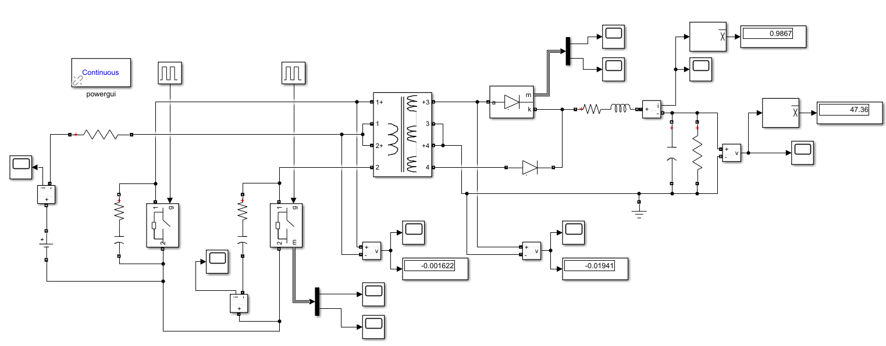

*Figure 10. Simulation model of the non-ideal push pull converter.*

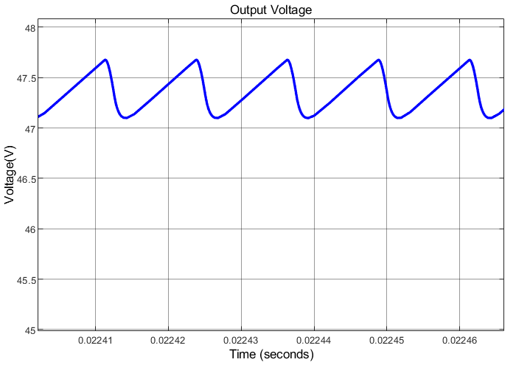

*Figure 11. Output voltage waveform of non-ideal push-pull converter.*

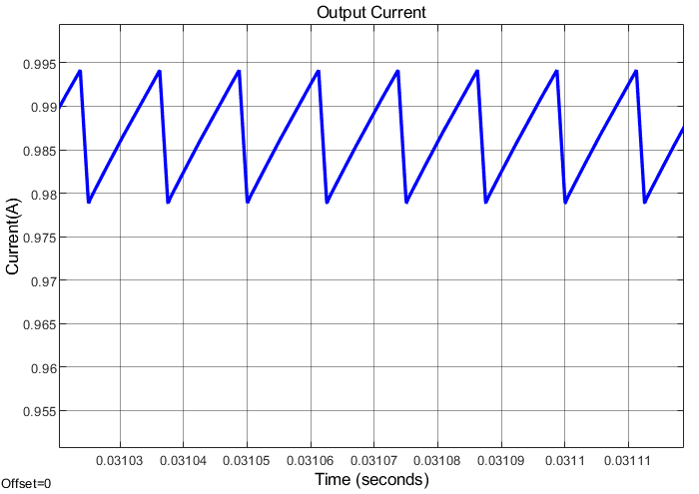

*Figure 12. Output current waveform of non-ideal push-pull converter.*

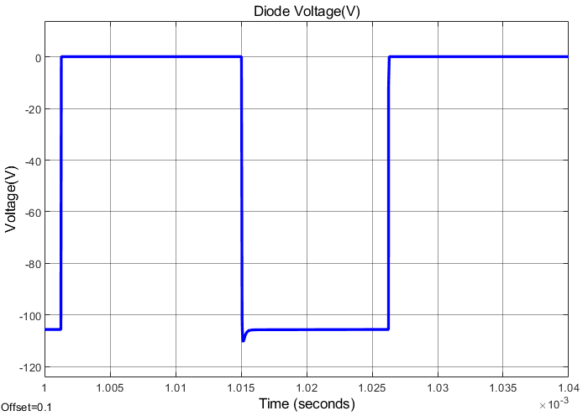

*Figure 13. Voltage waveform of one of the diodes that is in the secondary side.*

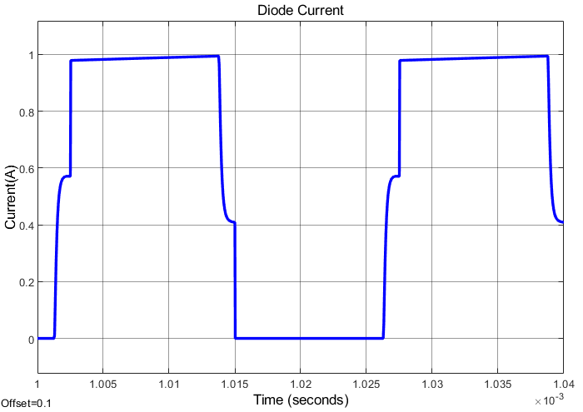

*Figure 14. Current waveform of one of the diodes that is in the secondary side.*

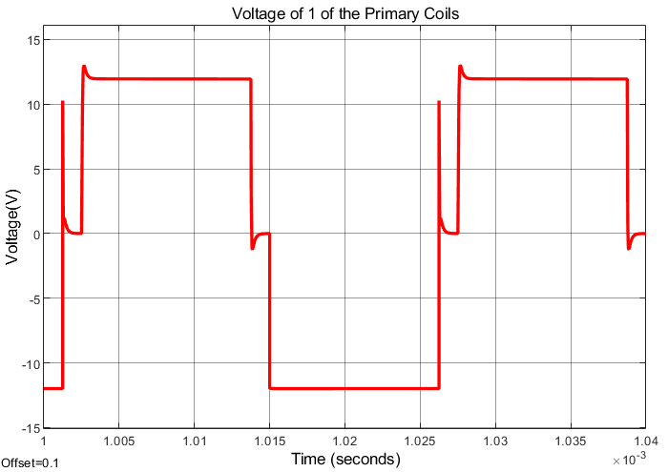

*Figure 15. Voltage waveform of one of the primary coils.*

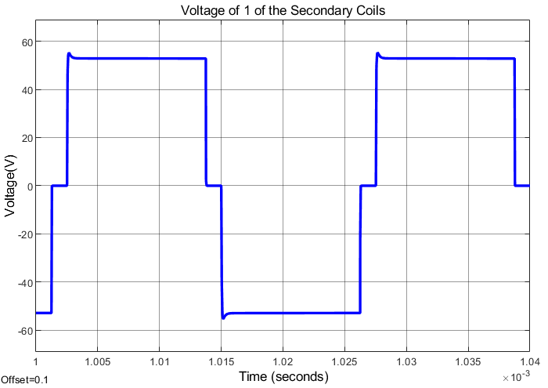

*Figure 16. Voltage waveform of one of the secondary coils.*

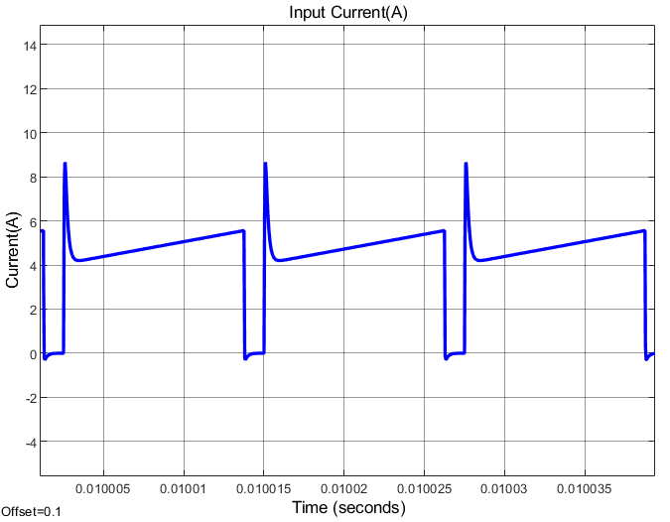

*Figure 17. Input current waveform of the non-ideal push-pull converter.*

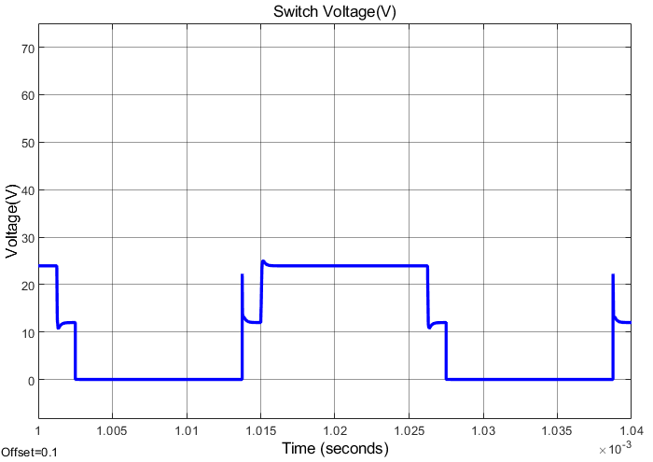

*Figure 18. Voltage waveform of one of the switches in the primary side.*

As can be seen from the graphics, a slight decrease has been observed in our output voltage. In addition, the negative effects caused by the parameters that cause non-ideality in the transformer are reduced by using the snubber circuit.

## e)

(Vin=12V, D=0.45, fsw=40kHz)

For the 100% load condition,

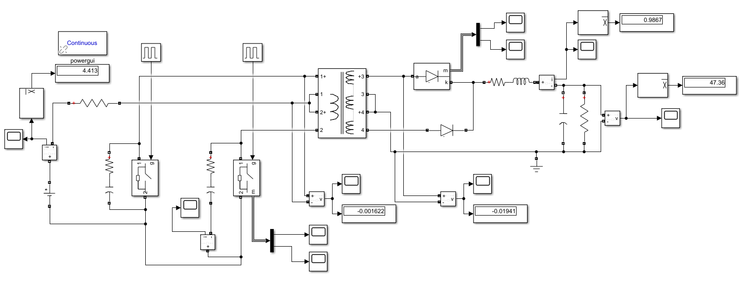

For the 75% load condition,

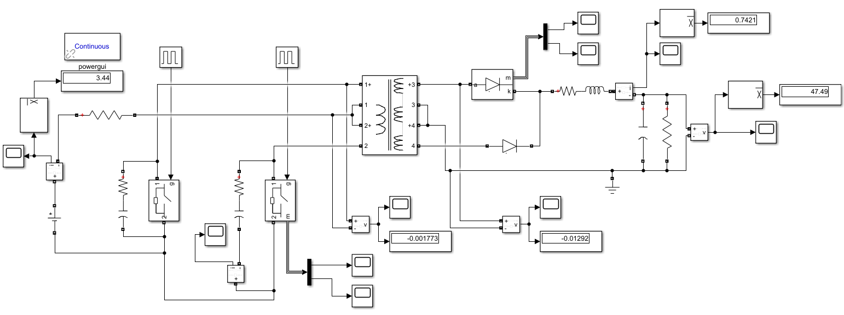

For the 50% load condition,

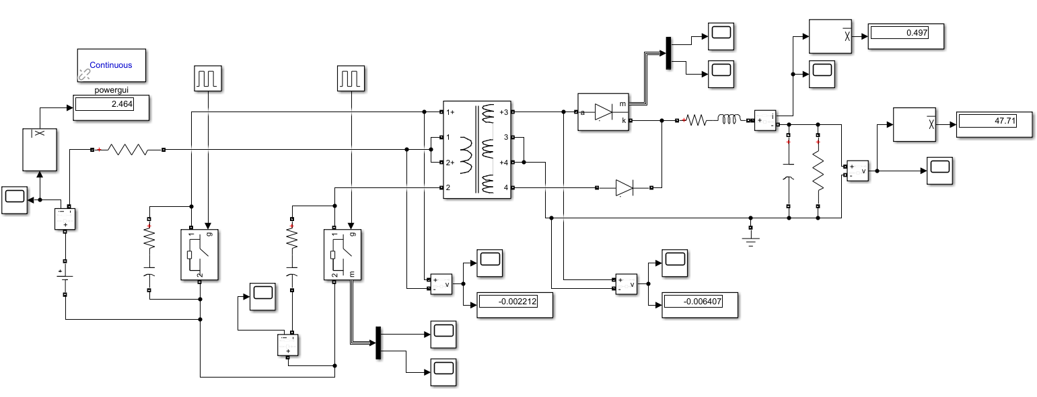

For the 25% load condition,

